**Name: P. Madhan Kumar**

**Emp ID: 11960**

**Self Preparation**

**Introduction to GIT:**

1. GIT - Global Information Tracker
2. It is a version Control System

Three States of GIT

* Working directory
* Staging area
* (.git directory)Repository

**GIT commands:**

1. $mkdir

Used to create a directory or folder

1. $ls

Used to list all files and folders of the current working directory.

1. $cd

Used to change the directory.

1. $ git init

Used to initialize the empty directory.

1. $ git add

Used to add the files in the directory and the staging area.

1. $git commit

Used to inform the changes that were saved in the local repository.

1. $ git status

Used to check the current status of the file .

1. $ git branch

Used to check the current branch from each team or projects.

1. $ git checkout

Used to switch branches.

1. $ touch <filename>

Used to add more files.

1. **Git Add** :

*Working directory

* Staging area

* Git repository

Commands :

Git init

Git add<filename>

Git Status

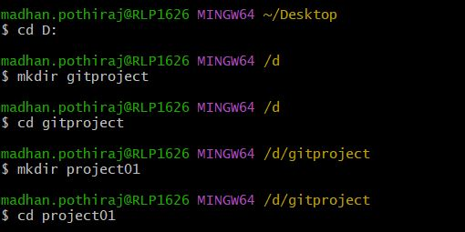

1. **Git Commit**:

Commands:

$git commit -m “Added files”

$git status

$git log

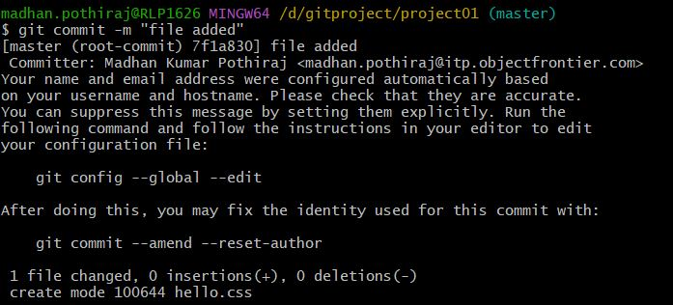

1. **Adding all files of same type:**

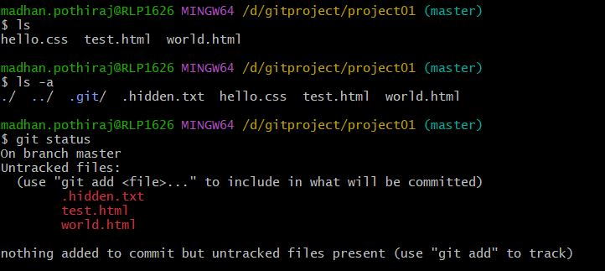

1. **Removing files from staging area:**

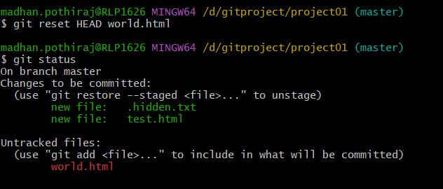

1. **Ignoring the files**

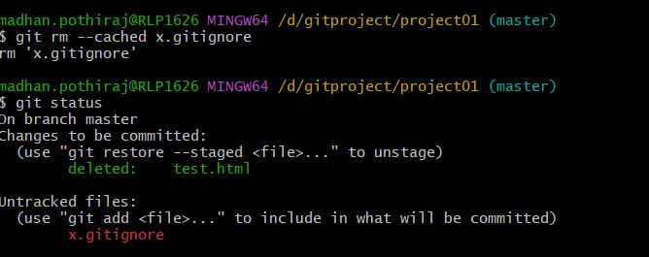

**Branches:**

* By default, master is the default branch in the repository.

1. **Listing all branches**

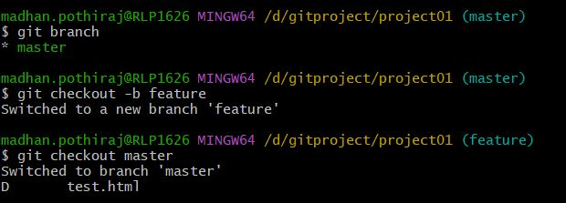

**20 ) Adding a new branch**

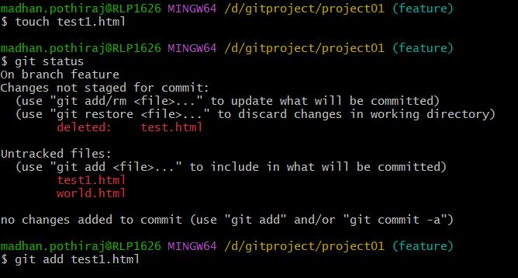

**21) changing branches:**

**Command:**

$ git checkout <filename>

22) **Merging and removing branches:**

